WHERE THE MOON THROW ITS LIGHT.

Some people think that walking in the Moon light is romantic and lovely. Its reflection in the water hypnotizes. But nobody knows why this pale lifeless object takes control not only of high and low tides, but also makes an influence on our mind. Men’s curiosity is always aroused by deserted and uninhabited place, because it gives a chance to create the whole world in their imagination.
Why a lot of us can’t sleep, when the full Moon throws its light on the body? And why we become so high-spirited, when we see the New Moon?
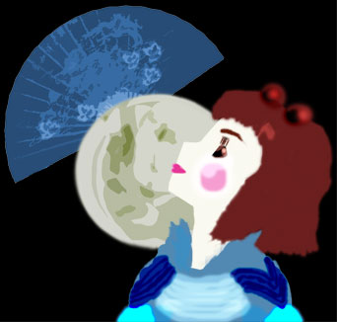
The full Moon patronizes necromancers and wizards. At this particular time witches were gathering on the tops of the mountains; this tradition was wide-spread in Old Germany.
According to the old beliefs owl, wolf and bear are the Moon animals.
Chinese legend says that the rabbit, which knows how to prepare the magical beverage, lives on the Moon. Some nationalities recognize the man on the Moon-disk, usually it is a weaver.
The hide of the Moon between clouds was connected with a swallow of the sky monster. It was supposed as protection from evil, to bash on the metallic dishes in the dark night.
Many moons ago it was supposed to be a bad sign to point at the Moon, because the soul of such a man will never find enter in Paradise.
New Moon symbolizes creation, luck and fertility. During this period people can be recovered from their diseases.
Crescent in old traditions denotes immortality and highest power. In some Southern countries the priest’s clothing was decorated with this sign.
The Moon is frequently compared with a woman, due to her tender and mysterious nature. The Moon with its phases was a prototype of lady’s enigmatic accessory – fan. So Lady Moon doesn’t want to open her soul and a lot of her secrets will be secrets for us.

