Unpack the archive with the program into your disk (Picture 1)
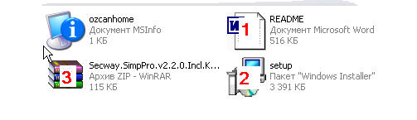
Picture 1
- this file - README.doc
- file setup.exe – launches the installation program
- archive with a keygen

Launch the file setup.exe by double click of the left button of your mouse. Such a window will appear (Picture 1a) with a suggestion to install the program.

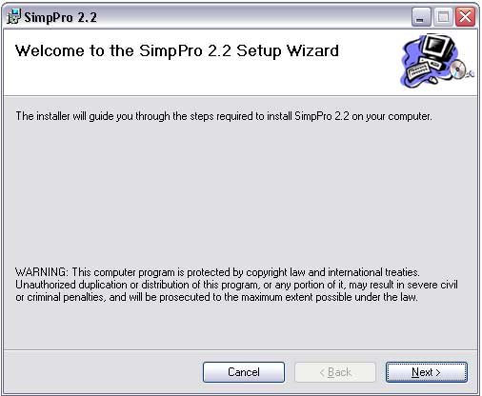

Picture 1a

Click “Next” and move to the next window (Picture 2), and accept the terms of the license.
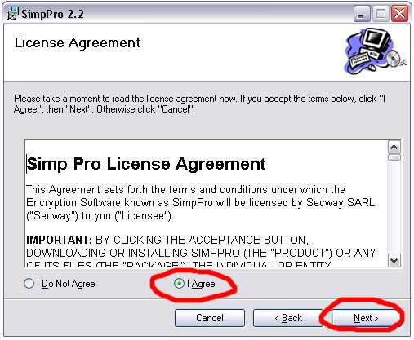

Picture 2

After this select what components to install (Picture 3)

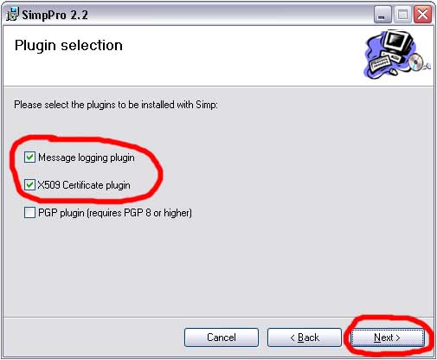

Picture 3

In the next window (Picture 4) select the destination folder and availability of the program (for yourself, or for anyone who uses this computer).
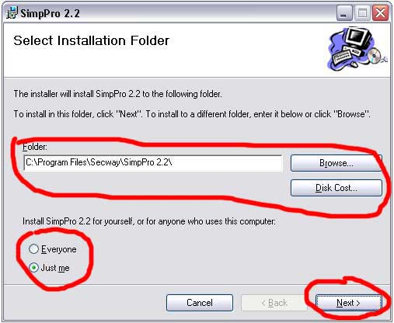

Picture 4

The next window (Picture 5) shows that everything has been selected, click “Next” to start the installation.
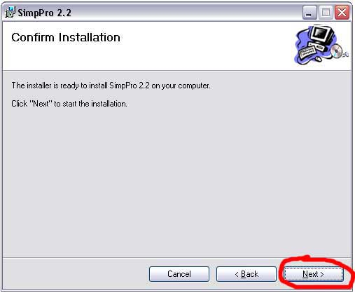

Picture 5

After copying all the files you will be asked to register the program (Picture 6), but do it later. That’s why click “Next”.
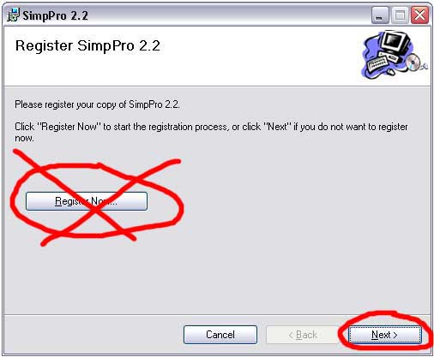

Picture 6

The next two windows show that the installation is complete, just click “Next”. And then click “Close” in the last window. After that launch the configuration wizard (Picture 7).

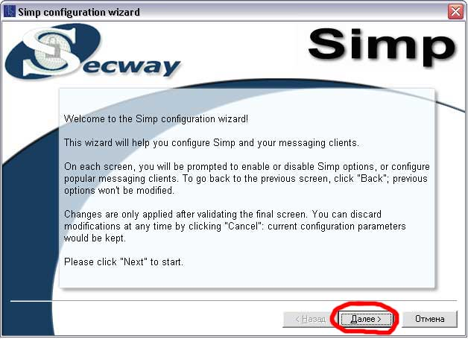

Picture 7

In the next window (Picture 8) enable or disable pop-up windows (they appear at the bottom of the screen if a new contact is added or your status is changed, etc.)
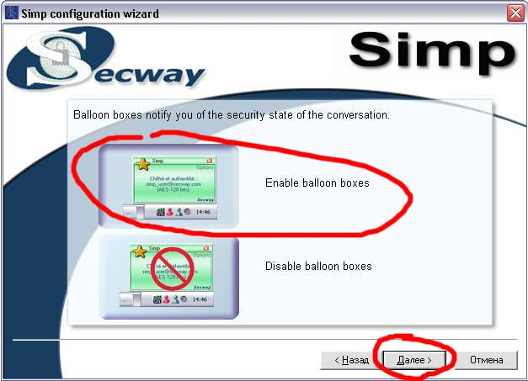

Picture 8

Then select your kind of internet connection. But it’s better when the program detects these settings itself (not to mix anything). That’s why select “I don’t know” and click “Next” (Pic.9)

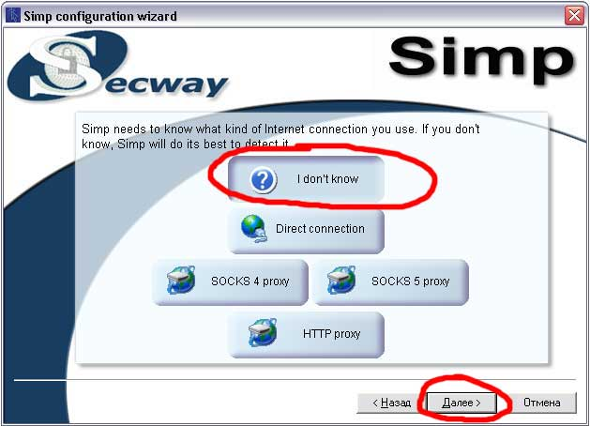

Picture 9

Study the next window carefully (Picture 10) and choose IM clients you use (if you use Miranda or another program which is not in the list choose “Unlisted ICQ/AIM client”)

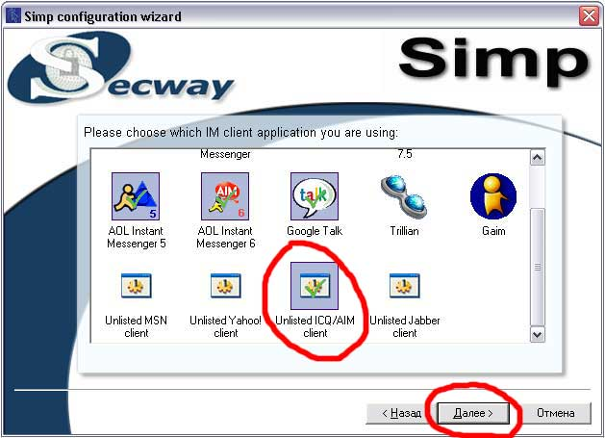

Picture 10

Simp Pro can detect what kind of program you use and its settings. It will show the settings. These settings for “Unlisted ICQ/AIM client” (Miranda, for instance) must be like on Picture 11.

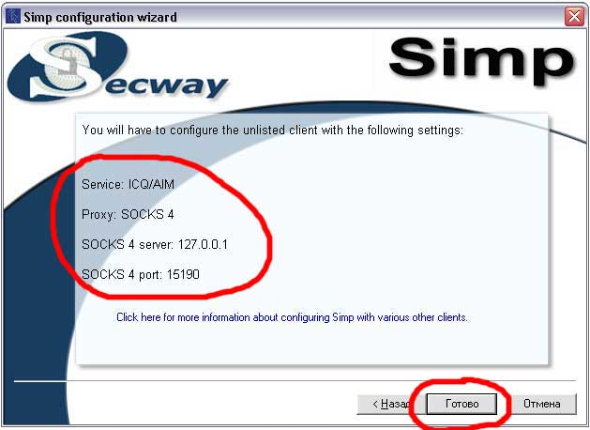

Picture 11

Memorize or write down the settings from Picture 11. You will need them while configuring your client. Simp Pro will be launched after this, and an icon in the tray will show it (Picture11a).



Picture 11a

Then you will be suggested generating necessary keys for the program (Picture 12).

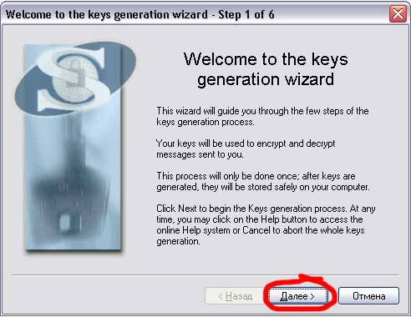

Picture 12

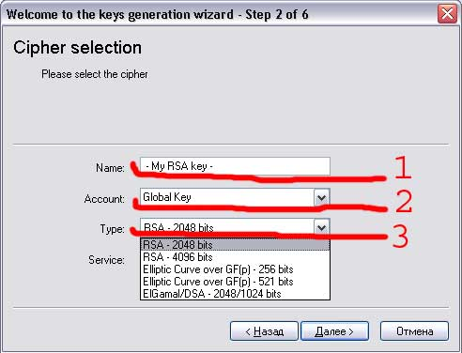

Picture 13

1. Choose and enter the name of your key
2. The type of the key (you may leave it as it is)
3. The type of encryption (RSA – 4096 bit is recommended)

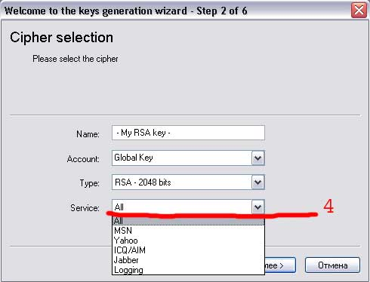

Picture 13а

- And also choose for which services to use this key (Picture 13a). Click “Next” and move to another window (Picture 14) in which enter the password of the key and confirm it.

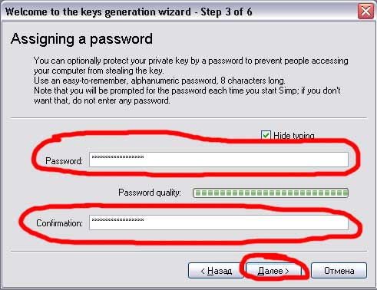

Picture 14

In the next window (Picture 15) generate some random numbers by moving the mouse to guarantee safe coding. After the key is generated it is activated and the button “Next” becomes available. Click on it. And click “Next” once more.
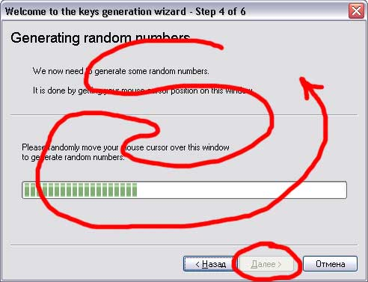

Picture 15

The next window shows that the key is generated. Click on “Complete” (Picture 16)

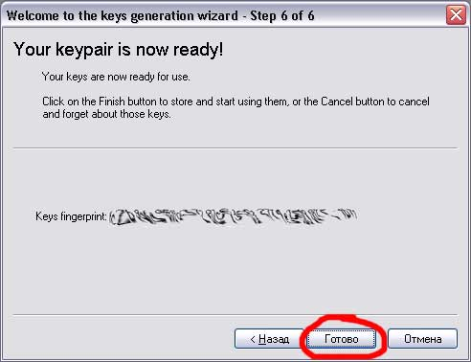

Picture 16

When the program asks you to register (when it is launched for the first time) open the archive with the keygen Secway.SimpPro.v2.2.0.Incl.Keygen-SSG.rar and launch it. Everything is easy: enter your name and the name of the company and click “Generate” (Picture 17). And then enter the key into the appropriate window of the program.

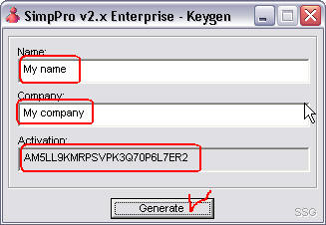
Picture 17
And now configure the program. The main window of the program looks like that (Picture 18)

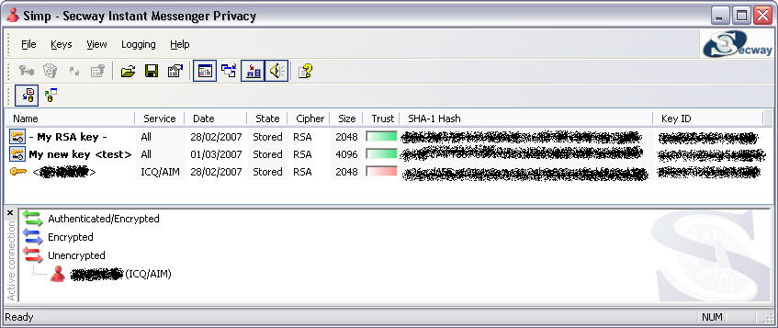

Picture 18

To enter the configuration window choose the item Configure in the menu File (Picture 19).

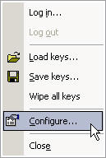
Picture 19

In the configuration window click on System (Picture 20)

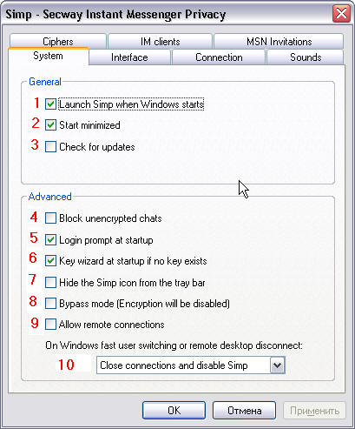

Picture 20

- Launch SimpPro when Windows starts (at your discretion)
- Start minimized (recommended)
- Check for updates (disable)
- Block unencrypted chats (at your discretion)
- Login prompt at startup (recommended)
- Key wizard at startup if no key exists (recommended)
- Hide the Simp icon from the tray bar (at your discretion)
- Bypass mode (disable)
- Allow remote connection (disable)
- On Windows fast user switching or remote desktop disconnect: close connections and disable Simp.

It’s recommended to configure the program as on the picture 20.

Then open IM clients (Picture 21)

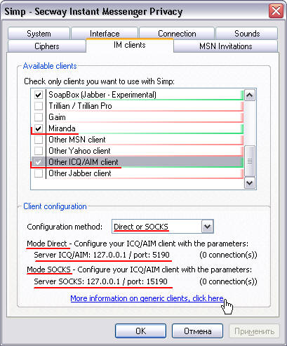

Picture 21

In the window Available clients choose only clients you want to use with Simp. If there is no such client in the list choose Other ICQ/AIM client.
You should configure you client as on the picture 21.

Here is an example how to configure your client (Picture 22). Click Settings -> Network.

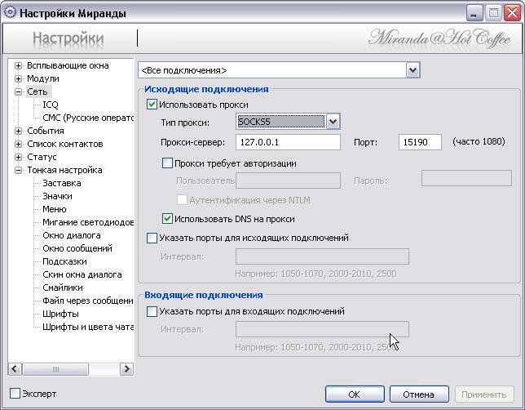

Picture 22

