Manual

National Library of Belarus WiFi network

National Library of Belarus (NLB) WiFi network is acceptable only to registered readers via their password, which is used for literature orders in the Electronic Catalog.

Password might contain numbers and letters (small register) of the Latin alphabet.

Password can be changed at users’ workstation:

launch the program Electronic Catalog (OPAC) ;

- close “NLB’s search engine” pop-up window;

- select a tab “Order” point “Data of Orders” in the menu;

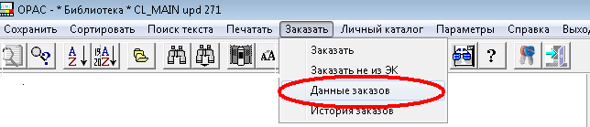

- enter the Library card number and password (if it wasn’t changed before – your surname in Belarusian) in the upcoming window;

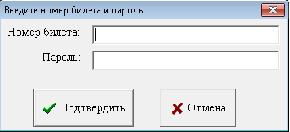

- click on “Сhange password” in the window “Data of the current day” (right bottom hand corner);

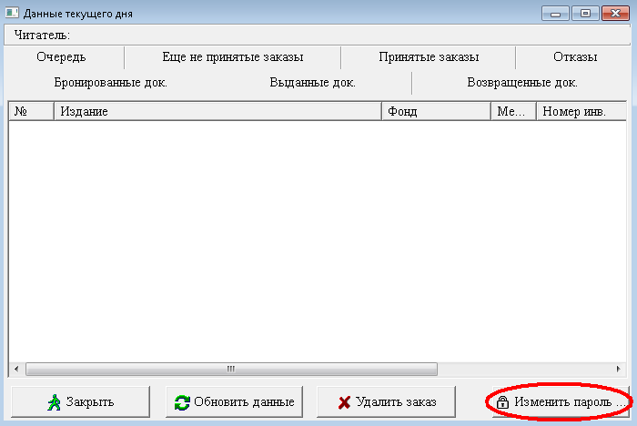

- enter your current password and twice a new one in the window “Change Password” and “Submit”;

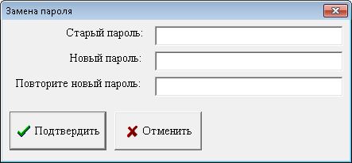

- new password will be used for documents order in the Electronic Catalog and for NLB’s network WiFi log on.

Contact a register office if you forgot a password.

- A login proceeding depends on the operating system, installed on your gadget.

Common rules for all devices:

- in the IP protocol of the WiFi adapter's network, choose a setting "automatically";
- in the list of accessible wireless select “NLB_Readers”;
- after connection to the "NLB_Readers" transition to the authentication page in some operating systems can come over automatically. In case it didn’t come over, launch browser, and then a page will be opened – https://wifi.nlb.by/index.html, or you can type it in the browser’s location bar.
- Then enter your user name (which corresponds your library card number mines zeroes before it) and a password;

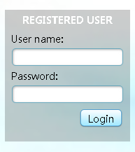

- in case of successful authentication “Authentication Success” will appear.

