slide 1


Good day, ladies and gentlemen.
Today, leading presentations will HO and GM.
The topic of our presentation is Yandex.

slide 2
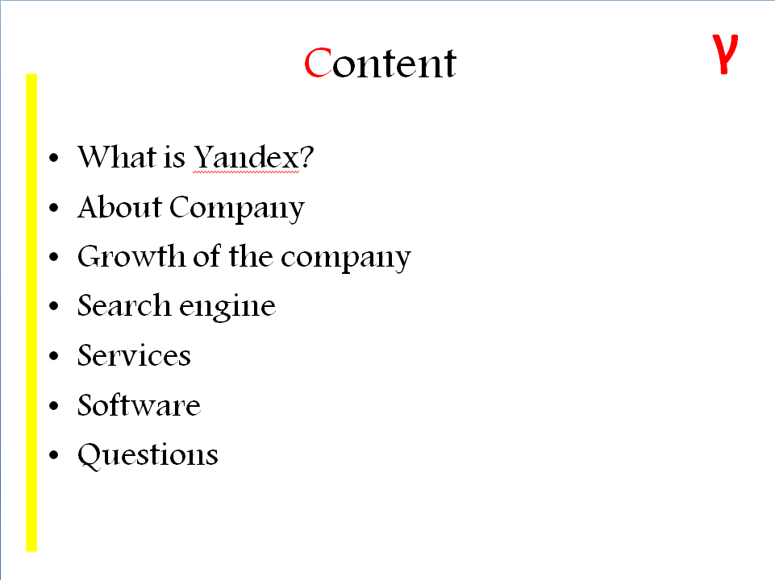
The presentation consists of the following sections:

slide 3

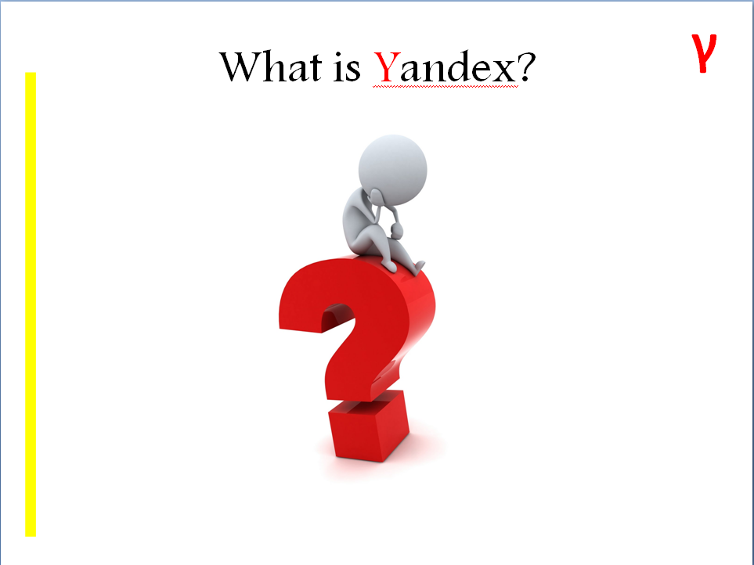
Yandex is one of the largest internet companies in Europe, operating Russia’s most popular search engine and its most visited website. According to LiveInternet, as of December 2013, they generated 61.9% of all search traffic in Russia. But they also operate in other country.
slide 4

Yandex's roots trace back to 1990, when Arkady Volozh and Arkady Borkovsky founded the company Arkadia, which developed MS-DOS software for use in patents and goods classification. Their software featured a full-text search with Russian morphology support. In 1993 Arkadia became a subdivision of Comptek International. In 1993-1996 the company continued developing its search technologies and released software for searching through the Bible and Russian classical literature.
In 1993 Arkady Volozh and Ilya Segalovich, friends since their school days and by then working together to develop search software, invented the word "Yandex" to describe their search technologies. The name initially stood for "Yet Another iNDEXer".
The search engine yandex.ru was launched on September 23, 1997 and was publicly presented at the Softool exhibition in Moscow. Initially the search engine was developed by Comptek. In 2000 Yandex was incorporated as a standalone company by Arkady Volozh.^{[16]}
Yandex's revenue comes primarily from online advertisement. In 1998 Yandex launched contextual advertisement on its search engine. In 2001 it launched the Yandex.Direct advertisement network. Yandex LLC became profitable in November 2002. In 2004, Yandex sales increased to $17M.The net income of the company in 2004 constituted $7M. In June 2006, the weekly revenue of Yandex.Direct context ads system exceeded $1M.
In September 2005 Yandex opened an office in the Ukraine and presented the Ukrainian portal, www.yandex.ua.
In March 2007 Yandex acquired moikrug.ru, a Russian social network, to search and support professional and personal contacts. In June 2008 Yandex acquired SMI Link, a Russian road traffic monitoring agency, to merge it with Yandex.Maps services.
In September 2008 Yandex further acquired the rights to the Punto Switcher software program, an automatic Russian to English keyboard layout switcher.
In August 2009 Yandex introduced a player of free legal music in its search results. A little over a year later Yandex launched the Yandex.Music service and significantly extended its music catalogue to 800,000 tracks from 58,000 performers.
On May 19, 2010, Yandex launched an English-only web search engine.
In 2010 Yandex launched the Yandex.Start program to find startups and to work with them systematically
In January 2011 Yandex introduced premium placement opportunity in its Business directory; advertisers' local small businesses will be highlighted on a map for relevant queries. It was announced that the potential audience of the product includes over 25 million users of Yandex's search engine and over 11.5 million of Yandex.Maps.
In spring 2011 Yandex raised $1.3 billion in an initial public offering on NASDAQ.
In September 2011 Yandex launched a search engine and a range of other services in Turkey, at yandex.com.tr. The company also opened an office in Istanbul.^{[9]}
In July 2013, Mail.Ru started placing Yandex.Direct ads on its search result pages. October 2013 Yandex acquired KinoPoisk, the biggest Russian movie search engine. Also in 2013, Yandex became the largest media property in Russia/.
In March 2014 Yandex acquired Israeli geolocation startup KitLocate.^{[50]}
In June 2014 Yandex acquired the online auto classifieds portal Auto.ru^{[51]}
slide 5
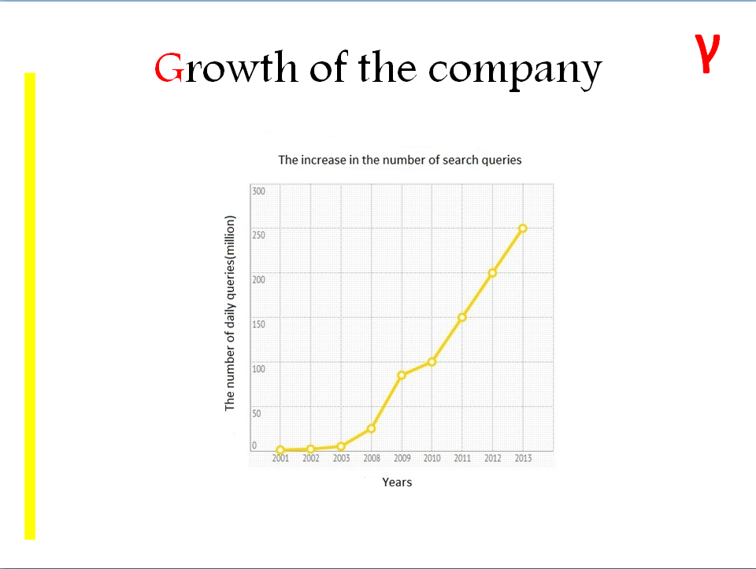
In this graph you can see the rapid growth Yandex since 2008, this is due to the constant development and expansion of the company.
Now Yandex provides a wide variety of services
slide 6

The first and most popular service of Yandex is Yandex Search.
The search technology provides local search results in more than 1,400 cities. Yandex Search also features “parallel” search that presents results from both main web index and specialized information resources, including news, shopping, blogs, images and videos on a single page.
slide 7
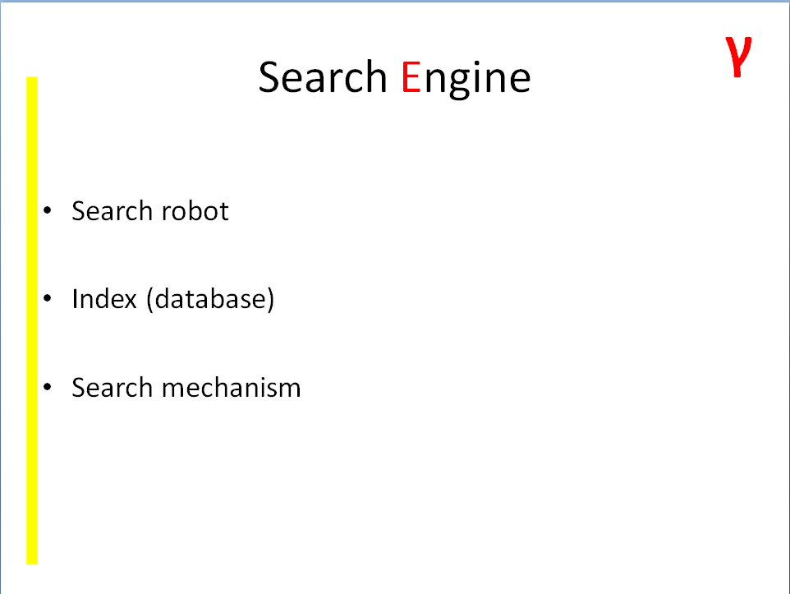
The search engine consists of three main components:
The first is search robot.
It bypasses the network, downloads and analyzes documents. In case of discovery of new links in the site analysis, it falls in the list of web addresses of the robot.
The second is index.
The index is a database collected by the robots indexers search engines. All the found documents are store in the index.
The third is Search mechanism.
Search mechanism is the interaction between the search engine and the user, and displaying the results on request.
slide 8

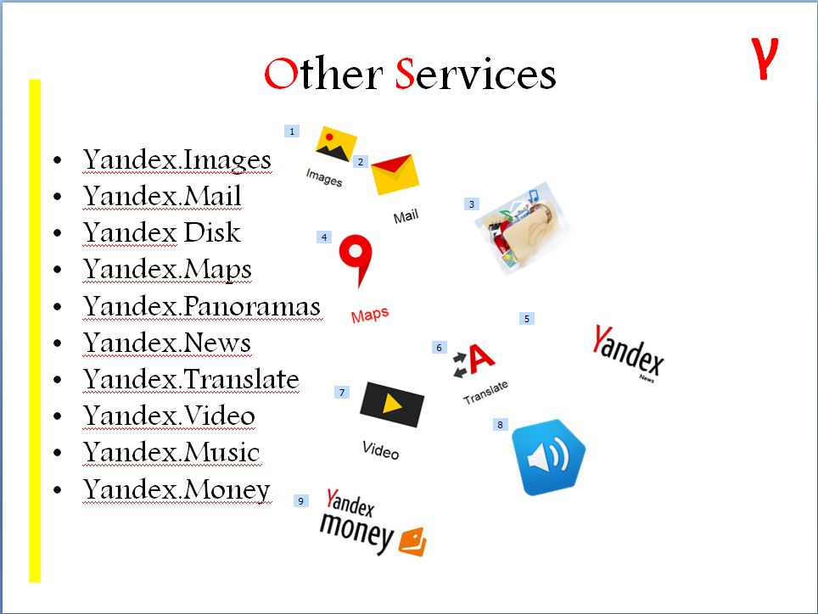
- Yandex.Images – search for images on the web, including search BY image itself
- Yandex.Mail - email service
- Yandex Disk - cloud storage
- Yandex.Maps - maps
- Yandex.Panoramas - web service allows you to view the panorama streets of cities in Russia, Ukraine, Belarus, Kazakhstan, and Turkey, which is the empowerment of the service Yandex.Maps
- Yandex.News - automatic data processing and systematization of the news media of different
- Yandex.Translate - online translator
- Yandex.Video - search for movies with the ability to view the majority found clips on the search results page
- Yandex.Music - service that helps you to search for free and legally listen to songs, albums and music tracks collections
- Yandex.Money - electronic payment service

slide 9
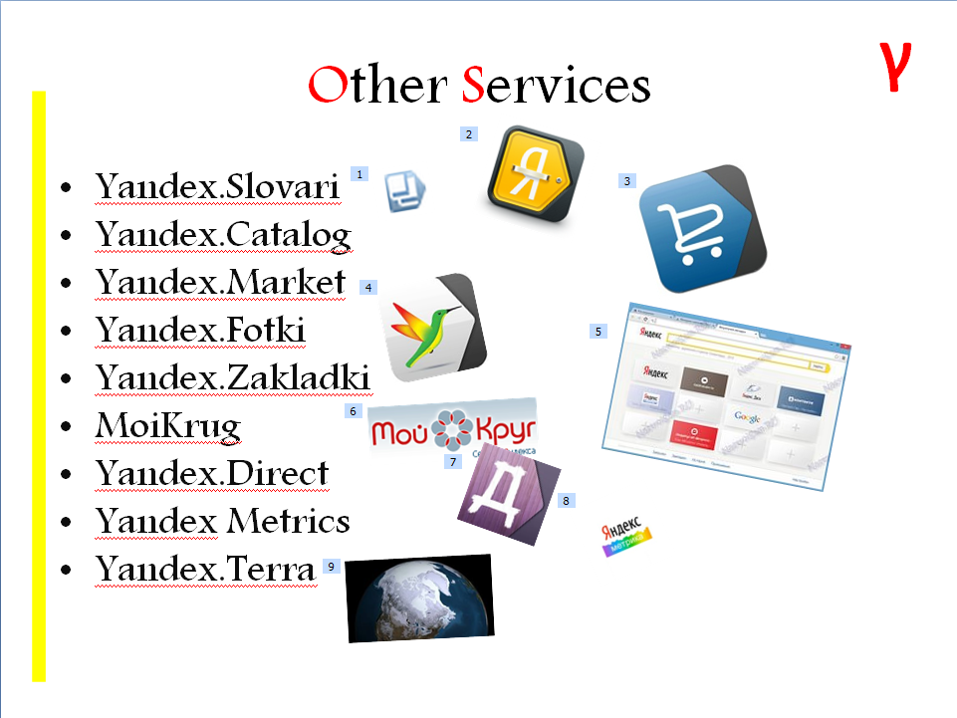
- Yandex.Slovari - service to search for information on sites and encyclopedic reference content as well as on the basis of digitized by Yandex dictionaries and reference books
- Yandex.Catalog - directory sites
- Yandex.Market - comparison service characteristics of the goods and their prices
- Yandex.Fotki - free photo hosting
- Yandex.Zakladki - project for storing custom bookmarks outside a browser (online)
- MoiKrug - social network aimed at establishing business contacts
- Yandex.Direct - automated, auction-based system for placement of text-based advertising
- Yandex Metrics - a free service designed to measure websites visits and analysis of user behavior
- Yandex.Terra - geological, geophysical and seismic data processing service

slide 10
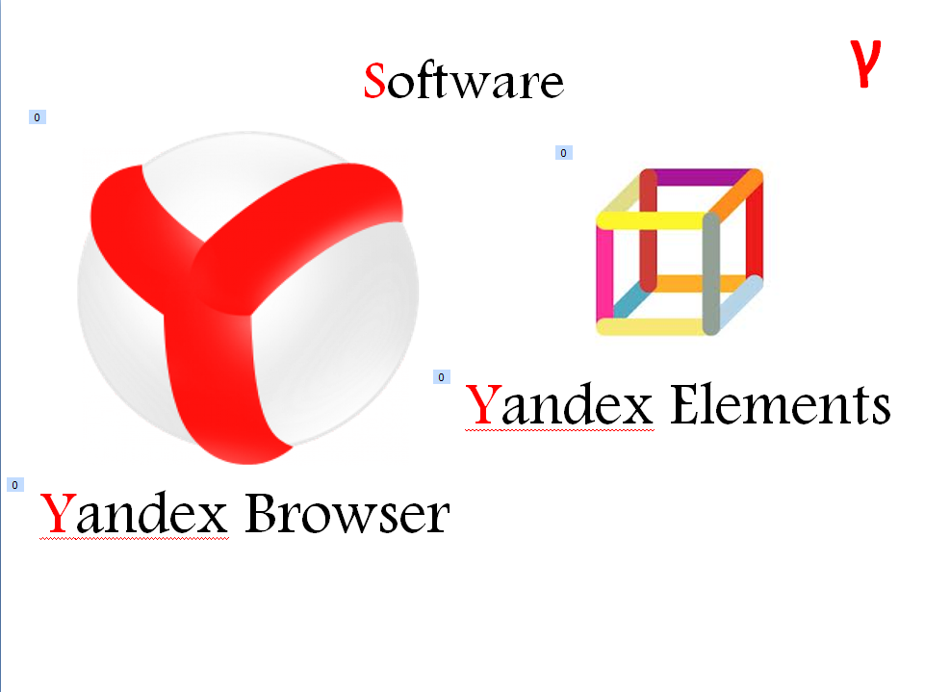
- Yandex Browser - a web browser that has a Blink layout engine and is based on the Chromium open source project. The Yandex browser alerts the user when they visit harmful sites and checks downloaded files with Kaspersky anti-virus. The browser also uses Opera Software's Turbo technology to speed web browsing on slow connections.
- Yandex Elements - add-on for web browsers Microsoft Internet Explorer, Mozilla Firefox, Opera and Google Chrome.

Desktop software
Adobe Photoshop, Adobe Lightroom, Adobe InDesign, Adobe Illustrator, Adobe Fireworks, Adobe Soundbooth, Adobe Acrobat and Adobe Audition
Server software
Adobe ColdFusion, Adobe Content Server and Adobe LiveCycle Enterprise Suite, Adobe BlazeDS
Formats
Portable Document Format (PDF), PDF's predecessor PostScript, ActionScript, Shockwave Flash (SWF) and Flash Video (FLV)
Web-hosted services
Adobe Kuler, Photoshop Express, and Acrobat.com
Web design programs
Adobe Dreamweaver, Adobe Contribute, Adobe Muse, Adobe Flash Builder, Adobe Flash Catalyst, Adobe Flash, and Adobe Edge
Video editing and visual effects
Adobe Premiere Pro, Adobe After Effects, Adobe Prelude, and Adobe SpeedGrade
eLearning software
Adobe Captivate
Organizational software
Adobe Extension Manager and Adobe After Effects
Web content management Software
Adobe Experience Manager (AEM)
Digital Advertising Optimization Software
Adobe Media Optimizer (AMO)
Video publishing & analytics platform
Adobe Primetime
Творчі продукти компанії включають

