Additional
247852
78 АЕ
Certificate of the right to inheritance
Saint-Petersburg, 9 June 2000 (the ninth of June two thousand).
I, Rassoshko Lyudmila Stepanovna, the notary of Saint-Petersburg, acting on the basis of licence Nr. 65, given out by the Administration of Justice of Saint-Petersburg’s City Hall of 23 April 1993, certify that на on the basis of the enactment Nr.532 of the Civil Code of Russian Socialist Federation of Soviet Republics (RSFSR)the residuary legatees in equal shares of property of Skorodinskiy Sergey Vasilevitch deceased on the 11 November 1999 are равных долях: wife – Skorodinskaya Yevgeniya Gennadievna, born on the 18 December 1954, passport code: III-ДП Nr. 626252 given out by police station Nr.5 of the Home Affairs department of Severomorskiy city executive committee of Murmansk Region on the 19 November 1980,
under-aged son- Skorodinskiy Aleksandr Sergeevitch, born on the 31 August 1987,
Certificate of birth Nr.: V-AK Nr. 474117 given out by the Registry Office of Leningrad on the 19 September 1987, registered in Saint-Petersburg, Bolshoy Prospect of Vasilevskiy Ostrov, building Nr.74, flat Nr. 10.

The estate applied by this Certificate consists of:
1/4 (one quarter) part of the flat Nr. 10 in the house Nr. 74 on the Bolshoy Prospect of Vasilevskiy Ostrov in Saint-Petersburg, owned by the testator on the basis of Contract Nr. 7 02657 dedicated to transfer the flat into the ownership of citizens, concluded on the 28 October 1993 with the Admininstration of the Baltiiskiy factory of Saint-Petersburg, registered by the Housing Committee of Saint-Petersburg’s City Hall in the registry book of Contracts on flat privatization investment number 21-Д for Nr. 2657, that is confirmed in the Extract from the United state Register of privileges, serial number: 78-НВ 0207 95, given out by the Justice office " City agency of real property estate registration" in Saint-Petersburg on the 08 June 2000, incoming number 1180273, conventional number 112140425, and Agreement on admeasurement (78АЕ 247851), certified by the notary Санкт-Петербурга Rassoshko L.S. on the 09 June 2000 in accordance to the registry Nr. 1- 3678.
The share mentioned is situated in the flat, placed on the 4th floor of the 5-floored house built in the 1953, consisting of three rooms with total area accounting 90,07 square meters, including living area accounting 59,66 square meters, kitchen with area accounting 10,54 square meters, with bathroom, balcony, without a lift.
Inventory value of 1/4 (one quarter) part of the flat on the day of death – 73 712 (seventy three thousands, seven hundred and twelve ) roubles 50 kopyeek , in accordance with the Certificate Nr. 1520, given out by the Planning and inventory organisationon of the Vasileostrovskiy district in Saint-Petersburg on the 21 april 2000.
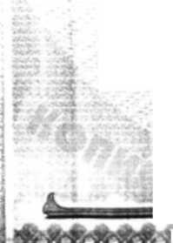
Annotation: the present certificate is subject to the state registration in order set by the Law. Primary Certificate of the right to inheritance was given out on the 31 May 2000 in accordance with the Certificate Nr. 1-3441.
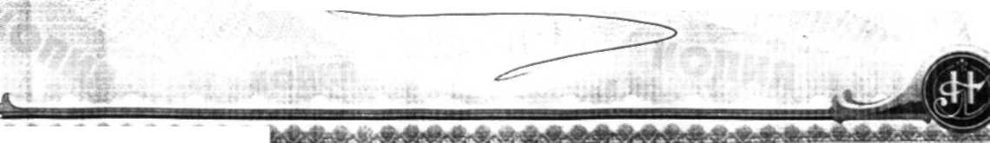
Recorded in the register foe Nr. 1- 3680 Probate case Nr. 201/99С.
И¹ Wiwiiwifltni i

